**NAME: ADITYA ABHIJIT PARULEKAR**

**DIV: S2-1**

**ROLL NO: 2201072**

* **EXPERIMENT – 1**

* **AIM:** To study and implement Selection sort & Insertion sort algorithms.

* ***THEORY:***

**1. Selection Sort Algorithm:** In selection sort, the smallest value among the unsorted elements of the array is selected in every pass and inserted to its appropriate position into the array. It is also the simplest algorithm. It is an in-place comparison sorting algorithm. In this algorithm, the array is divided into two parts, first is sorted part, and another one is the unsorted part. Initially, the sorted part of the array is empty, and unsorted part is the given array. Sorted part is placed at the left, while the unsorted part is placed at the right.

In selection sort, the first smallest element is selected from the unsorted array and placed at the first position. After that second smallest element is selected and placed in the second position. The process continues until the array is entirely sorted.

The average and worst-case complexity of selection sort is **O(n2)**, where **n** is the number of items. Due to this, it is not suitable for large data sets.

Selection sort is generally used when -

* A small array is to be sorted
* Swapping cost doesn't matter
* It is compulsory to check all elements

Now, let's see the algorithm of selection sort.

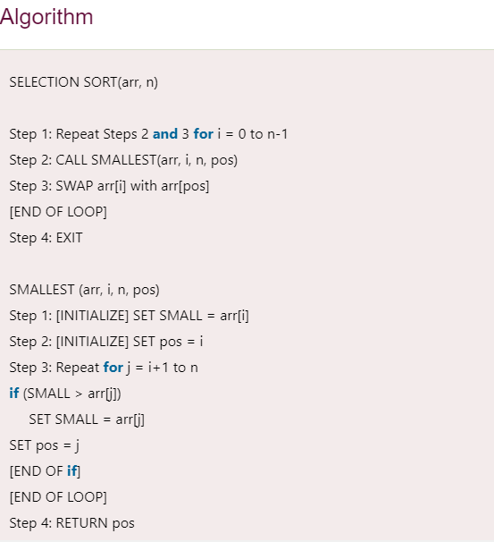

**Working of Selection sort Algorithm:**

Now, let's see the working of the Selection sort Algorithm.

To understand the working of the Selection sort algorithm, let's take an unsorted array. It will be easier to understand the Selection sort via an example.

Let the elements of array are –

selection Sort Algorithm

Now, for the first position in the sorted array, the entire array is to be scanned sequentially.

At present, **12** is stored at the first position, after searching the entire array, it is found that **8** is the smallest value.

selection Sort Algorithm

So, swap 12 with 8. After the first iteration, 8 will appear at the first position in the sorted array.

selection Sort Algorithm

For the second position, where 29 is stored presently, we again sequentially scan the rest of the items of unsorted array. After scanning, we find that 12 is the second lowest element in the array that should be appeared at second position.

selection Sort Algorithm

Now, swap 29 with 12. After the second iteration, 12 will appear at the second position in the sorted array. So, after two iterations, the two smallest values are placed at the beginning in a sorted way.

selection Sort Algorithm

The same process is applied to the rest of the array elements. Now, we are showing a pictorial representation of the entire sorting process.

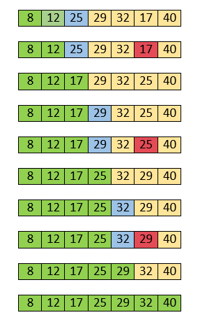

Now, the array is completely sorted.

**Selection sort complexity:**

Now, let's see the time complexity of selection sort in best case, average case, and in worst case. We will also see the space complexity of the selection sort.

**i. Time Complexity:**

|  |  |
| --- | --- |
|  | **Case Time Complexity** |
| **Best Case** | O(n2) |
| **Average Case** | O(n2) |
| **Worst Case** | O(n2) |

* **Best Case Complexity -** It occurs when there is no sorting required, i.e. the array is already sorted. The best-case time complexity of selection sort is **O(n2)**.
* **Average Case Complexity -** It occurs when the array elements are in jumbled order that is not properly ascending and not properly descending. The average case time complexity of selection sort is **O(n2)**.
* **Worst Case Complexity -** It occurs when the array elements are required to be sorted in reverse order. That means suppose you have to sort the array elements in ascending order, but its elements are in descending order. The worst-case time complexity of selection sort is **O(n2)**.

**ii. Space Complexity:**

|  |  |  |
| --- | --- | --- |
| **Space Complexity** | O(1) | |
| **Stable** | | YES |

* The space complexity of selection sort is O(1). It is because, in selection sort, an extra variable is required for swapping.
* **C PROGRAM (SELECTION SORT) :**

//SELECTION SORT

#include <stdio.h>

int main()

{

int arr[] = {21,67,45,15,64,11,78};

int n = sizeof(arr) / sizeof(arr[0]);

printf("\n\nAditya Parulekar\nS21-2201072\n\n");

printf("---------------- SELECTION SORT PROGRAM ----------------\n");

printf("\nBEFORE SELECTION SORT: ");

printArr(arr,n);

selSort(arr,n);

printf("\nAFTER SELECTION SORT: ");

printArr(arr,n);

}

void swap (int *x, int *y) {

int temp = *x;

*x = *y;

*y = temp;

}

void selSort(int arr[], int n)

{

int i,j,min;

for (i=0;i<n-1;i++)

{

min = i;

for(j=i+1;j<n;j++)

if (arr[j] < arr[min])

min = j;

if(min != i)

swap (&arr[min], &arr[i]);

}

}

void printArr(int arr[], int n)

{

int i;

for (i = 0; i < n; i++)

printf("%d ", arr[i]);

}

* **OUTPUT:**

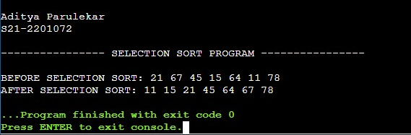

**2. Insertion Sort Algorithm:** Insertion sort works similar to the sorting of playing cards in hands. It is assumed that the first card is already sorted in the card game, and then we select an unsorted card. If the selected unsorted card is greater than the first card, it will be placed at the right side; otherwise, it will be placed at the left side. Similarly, all unsorted cards are taken and put in their exact place.

The same approach is applied in insertion sort. The idea behind the insertion sort is that first take one element, iterate it through the sorted array. Although it is simple to use, it is not appropriate for large data sets as the time complexity of insertion sort in the average case and worst case is **O(n2)**, where n is the number of items. Insertion sort is less efficient than the other sorting algorithms like heap sort, quick sort, merge sort, etc.

Insertion sort has various advantages such as –

* Simple implementation
* Efficient for small data sets
* Adaptive, i.e., it is appropriate for data sets that are already substantially sorted.

Now, let's see the algorithm of insertion sort.

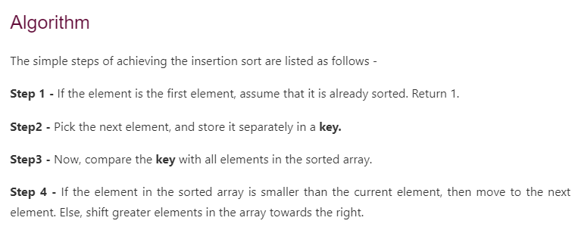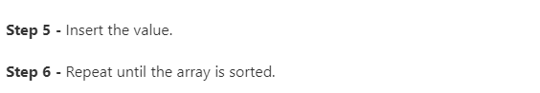

**Working of Insertion sort Algorithm:**

Now, let's see the working of the insertion sort Algorithm.

To understand the working of the insertion sort algorithm, let's take an unsorted array. It will be easier to understand the insertion sort via an example.

Let the elements of array are -

Insertion Sort Algorithm

Initially, the first two elements are compared in insertion sort.

Insertion Sort Algorithm

Here, 31 is greater than 12. That means both elements are already in ascending order. So, for now, 12 is stored in a sorted sub-array.

Insertion Sort Algorithm

Now, move to the next two elements and compare them.

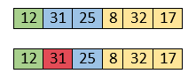

Here, 25 is smaller than 31. So, 31 is not at correct position. Now, swap 31 with 25. Along with swapping, insertion sort will also check it with all elements in the sorted array.

For now, the sorted array has only one element, i.e. 12. So, 25 is greater than 12. Hence, the sorted array remains sorted after swapping.

Insertion Sort Algorithm

Now, two elements in the sorted array are 12 and 25. Move forward to the next elements that are 31 and 8.

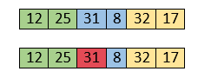

Both 31 and 8 are not sorted. So, swap them.

Insertion Sort Algorithm

After swapping, elements 25 and 8 are unsorted.

Insertion Sort Algorithm

So, swap them.

Insertion Sort Algorithm

Now, elements 12 and 8 are unsorted.

Insertion Sort Algorithm

So, swap them too.

Insertion Sort Algorithm

Now, the sorted array has three items that are 8, 12 and 25. Move to the next items that are 31 and 32.

Insertion Sort Algorithm

Hence, they are already sorted. Now, the sorted array includes 8, 12, 25 and 31.

Insertion Sort Algorithm

Move to the next elements that are 32 and 17.

Insertion Sort Algorithm

17 is smaller than 32. So, swap them.

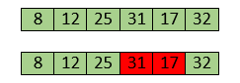

Swapping makes 31 and 17 unsorted. So, swap them too.

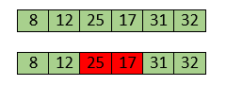

Now, swapping makes 25 and 17 unsorted. So, perform swapping again.

Insertion Sort Algorithm

Now, the array is completely sorted.

**Insertion sort complexity:**

Now, let's see the time complexity of insertion sort in best case, average case, and in worst case. We will also see the space complexity of insertion sort.

**i. Time Complexity:**

|  |  |
| --- | --- |
|  | **Case Time Complexity** |
| **Best Case** | O(n) |
| **Average Case** | O(n2) |
| **Worst Case** | O(n2) |

* **Best Case Complexity -** It occurs when there is no sorting required, i.e. the array is already sorted. The best-case time complexity of insertion sort is **O(n)**.
* **Average Case Complexity -** It occurs when the array elements are in jumbled order that is not properly ascending and not properly descending. The average case time complexity of insertion sort is **O(n2)**.
* **Worst Case Complexity -** It occurs when the array elements are required to be sorted in reverse order. That means suppose you have to sort the array elements in ascending order, but its elements are in descending order. The worst-case time complexity of insertion sort is **O(n2)**.

**ii. Space Complexity:**

|  |  |  |  |
| --- | --- | --- | --- |
| **Space Complexity** O(1) | | |  |
| **Stable** | YES |

* The space complexity of insertion sort is O(1). It is because, in insertion sort, an extra variable is required for swapping.
* **C PROGRAM (INSERTION SORT) :**

//INSERTION SORT

#include <stdio.h>

int main(){

int arr[] = { 78, 90, 12, 42, 30, 65, 92, 7, 45 };

int n = sizeof(arr) / sizeof(arr[0]);

printf("\n\nAditya Parulekar\nS21-2201072\n\n");

printf("------------ INSERTION SORT ------------");

printf("\nArray elements before applying Insertion sort :- ");

printArr(arr, n);

insSort(arr, n);

printf("\nArray elements after applying Insertion sort :- ");

printArr(arr, n);

return 0;

}

void printArr(int arr[], int n)

{

int i;

for (i = 0; i < n; i++)

printf("%d ", arr[i]);

}

void insSort(int arr[], int n)

{

int i, key, j;

for (i = 1; i < n; i++)

{

key = arr[i];

j = i - 1;

while (j >= 0 && arr[j] > key)

{

arr[j + 1] = arr[j];

j = j - 1;

}

arr[j + 1] = key;

}

}

* **OUTPUT:**

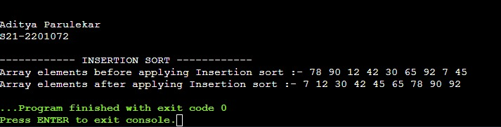

* ***CONCLUSIONS:*** We have successfully implemented Selection sort & Insertion sort algorithms.